Clado...clado…what?

Arizona Science Standards:
- S4-C4-PO3, 5, 6

Ag Standards:
- 17.4 –Portray the scientific principles and processes involved with biological evolution

Objectives:
- Understand the terms common ancestry, homologous structures, shared derived characters and cladogram
- Construct a cladogram
- Properly interpret and analyze cladograms.

Background:
One way to discover how groups of organisms are related to each other (phylogeny) is to compare the anatomical structures (body organs and parts) of many different organisms. Corresponding organs and other body parts that are alike in basic structure and origin are said to be homologous structures. Examples of homologous structures are the front legs of a horse, wings of a bird, flippers of a whale and the arms of a person. When different organisms share a large number of homologous structures, it is considered strong evidence that they are related to each other. When organisms are related to each other it means that they have a common ancestor at some point in the past. If there are specific modifications of those features shared by different groups of organisms, we say that those features are “shared derived characters”.
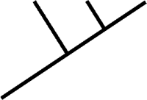
When we do studies in comparative anatomy, and find different numbers of shared derived characters exist between different groups we can draw a diagram of branching lines which connect those groups, showing their different degrees of relationships. These kinds of diagrams look like trees called “phylogenetic trees”, or “cladograms.” The organisms are located at the tip of each branch and if we follow the branches backwards then we can find the point of common ancestry. Keep in mind that the shared derived features of the homologous structures are shown on the cladogram by solid square boxes along the branches, and the common ancestors are shown by open circles. The more derived structures two organisms share, the closer their evolutionary relationship is – this means that their common ancestor lived more recently. On the cladogram, close relationships are shown by a recent fork from the supporting branch; the closer the fork in the branch between two organisms, the closer their relationship.

Pre- Lab Questions:
  - What is an anatomical structure?

  - Define homologous structure in your own words

  - What is a common ancestor?

  - What can a cladogram tell us?

Activity:

Let’s take a look at an example of a cladogram and analyze it before we move on to making our own. .
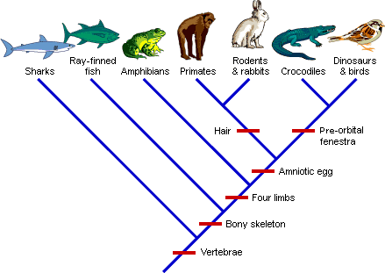
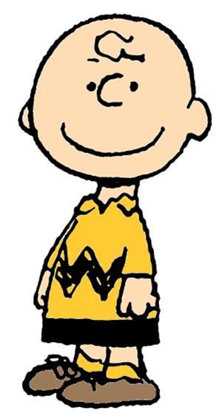
Humans
Birds
Caimans
Hares
Sharks
Tuna
Frog

Let’s see how it works…look at the lineages of the hare, caimans and birds.

Which organism is more closely related to the caimans? _________________

How do you know?

Because all life is related to some degree, all three of these animals also share a common ancestor; it is just an earlier one.

Circle where the common ancestor would be found for the three animals we have been looking at?
Just like tables or graphs, cladograms help us organize information. But why did we draw the cladogram this way?

Cladograms represent hypotheses about evolutionary relationships – who is more closely related to whom.

These relationships are based on shared features that have been inherited from a common ancestor.

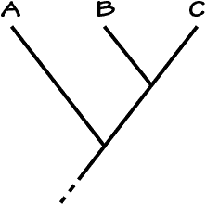
Feature 1
Common Ancestor
To the left, the short bar on the cladogram shows that feature 1 evolved before the common ancestor for A, B and C. This also means that everything about the red line will all share that change. This is how they become inherited.

Feature 2
Common ancestor

In the cladogram to the right, feature 2 evolved before the common ancestor of B and C and is therefore inherited by B and C but not by A.

Feature 3
In comparison, feature 3 evolved in the lineage leading to organism C. So, only organism C will have that derived characteristic.

Feature 3
Feature 2
Feature 1

How do these help us figure out which are more closely related? Feature 1 provides evidence that A,B and C are more closely related to each other than to other organisms and feature 2 tells use that B and C are more closely related to each other than to A. Feature 3 is unique to C.

Lets see how this information relates to the very first cladogram we looked at. Notice how all these animals and their lineages share at least one feature…they are all vertebrates. However, there are other features that are shared by only certain lineages. For example, frogs, humans, hares, caimans and birds all have four limbs. This makes them tetrapods. So, all tetrapods are more closely related to one another than they are to either sharks or tuna.
Humans
Birds
Caimans
Hares
Sharks
Tuna
Frog
Two skull openings
Amniotic egg
Four limbs
Bony skeleton
vertebrae
Hair

Which feature do humans, hares, caimans and birds share that the other three lineages did not inherit? __________________

Another way to use the cladogram is to look at different aspects of an organism. Skulls reveal other features that indicate ancestry. All animals have openings for eyes and nostrils, but some groups have inherited additional skull openings.

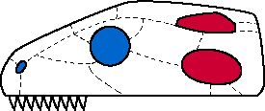
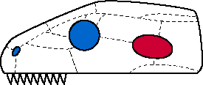
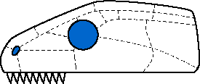

- Which do you believe is the frog skull? ________________
- Which do you believe is the skull that belongs to the humans and hares? ____________
- Which do you believe is the skull that belongs to the caimans and birds? _________
  - How did you come to this conclusion?
Keep in mind that because the vertebrates within these groups have continued to evolve and change, it is not always possible to see the openings. So, how do we know that the skull openings were present in the common ancestors if we can not see them today? FOSSILS!!!

By looking at early relatives of caimans and birds, we see that they all have two openings on the side of the skull. These later got lost in the lineages leading to crocodiles (such as caimans) and birds. The same is true for humans and hares. However, there are skull features we can study in modern animals. One of these is the skull opening in front of the eye.

Look at the skulls of these tetra pods: the frog, human, hare, fossil crocodile and the bird. Once again, all animals have openings for the eyes and the nostrils. However, some also have an opening in front of the eye on either side of the skull. You can see where the arrows are pointing these out.

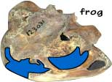
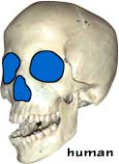
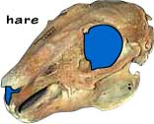
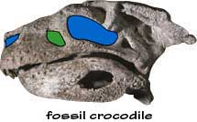
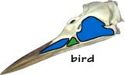

- Which of them have the opening? ___________________
- If you were going to write, “Opening in front of eye”, on the cladogram, where would you write it? __________________________________________

What are you going to do?:

Using the information that is around the room, place an X in the correct spot in the chart. The first one has been done for you.

Traits | Definition of trait | Kangaroo   | Lamprey  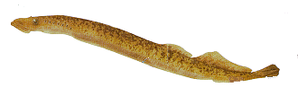 | Rhesus monkey   | Bullfrog   | Human   | Snapping turtle  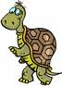 | Tuna  
Dorsal Nerve Cord | Nerve cord running along the back | X | X | X | X | X | X | X
Notochord

Paired Appendages

Vertebral column

Paired legs

Amnion (amniotic sac)

Mammary Glands

Placenta

Canine teeth short

Foramen magnum fwd

Now using the chart, create your cladogram. Keep in mind, that the trait that has the most X’s should be far away from all organisms. This is because they ALL inherited the trait.

Personal Cladogram:

Class Cladogram:

